WATER ROBOT

Here in this project we are implementing our water robot by using microcontroller programming system interfaced with night vision camera, gun (laser), GPS system, T.V tuner card, R.F module, motors and propellers.
IR module will detect the object and will send the exact distance to the PC through RF.
The data from the boat will be transferred through RF module.

The motive is to achieve proper communication between the PC and the robot boat.
This can be realized by setting up a wireless communication between PC and microcontroller which controls the movement of the boat.

The movement of boat is controlled with the help of synchronized pulses given by the

microcontroller to the stepper motor and DC motor connected to the boat.

Hence it is concluded that PCB design should contain following modules.

- POWER SUPPLY
- MICROCONTROLLER
- RF MODULE
- MOTOR DRIVERS
- STEPPER MOTOR DRIVER
- IR MODULE
- RELAY CIRUIT

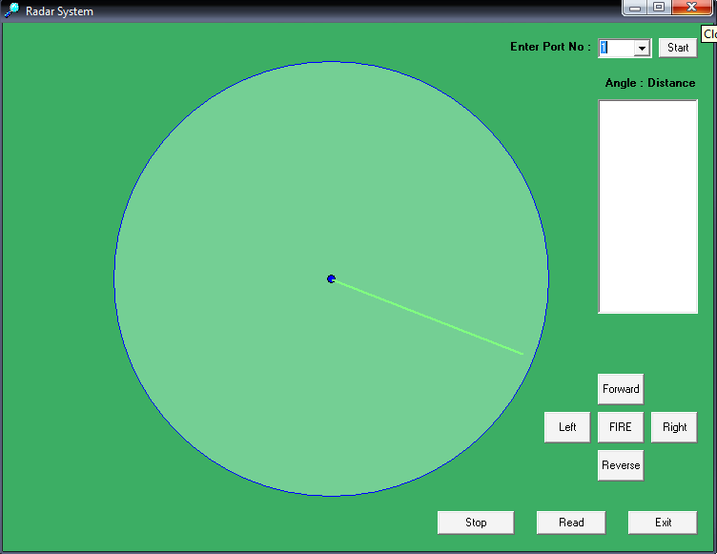

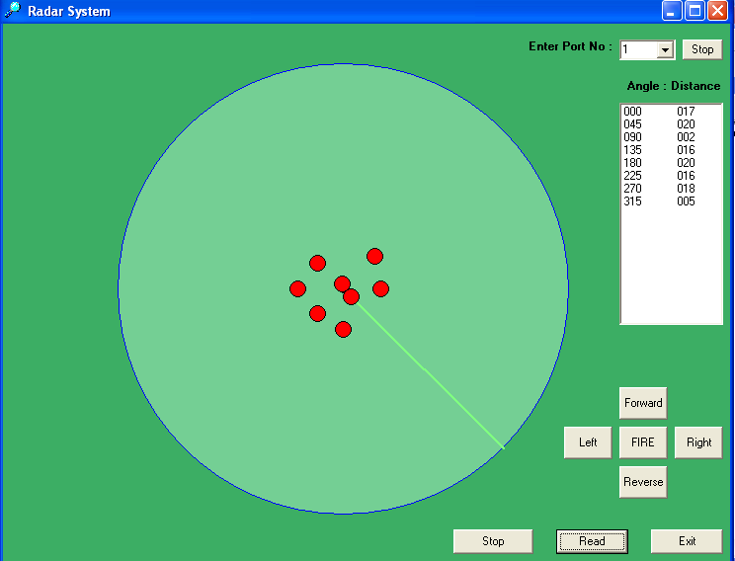

BLOCK DIAGRAM
- Robotic-Section:-
GUN
RELAY
DC MOTOR
I.R
RELAY DRIVER
MOTOR DRIVE

MICRO-CONTROLLER
RF- TRANS RECEIVER
CAMERA

MAGNETIC COMPASS

PROPELLER
CONTROL

STEPPER MOTOR
[ I.R CONTROL]

LASER
